DEVELOPING A FARMER FRIENDLY WEB-BASED PLATFORM

EUGENE JOSEPH GITHAE

SCT121-0510/2023

SUPERVISOR:

A Proposal Submitted to the Department of Information Technology in the School of Computing and Information Technology in partial Fulfillment of the requirements for the award of Diploma of Information Technology at the Jomo Kenyatta University of Agriculture and Technology

2025
DECLARATION

The work contained in this proposal report has not been previously submitted for any award at any higher educational institution. To the best of my knowledge and belief, the project report contains no material previously published or written by another person except where due reference is made.

Signed......................................................................... Date.........................................................

This proposal has been submitted for examination with my approval as University Supervisor

Signed......................................................................... Date.........................................................

ABSTRACT
Farmers find it had to access new markets for them products. We are going to build a website that helps local farmers advertise their products directly to the customer. Its like an online market where farmers can easily sell them goods. Farmers can post pictures and prices of the foods, vegetables, or other products. Buyers, like restaurants or people in town, can then find and buy directly from the farmers. We made the website simple to use, even if you're not used to computers. This helps farmers get better prices for their hard work and brings fresh, local food to more people in our community

Table of Contents
DECLARATION………………………………………………………………………………... ii
ABSTRACT……………………………………………………………………………………. iii
Introduction………………………………………………………………………………………1
CHAPTER 1…………………………………………...……...………………………………… 1
1.1 Background and Information...……………………..........………………………………… 1
1.2 Problem Statement …….……….…………….……………………………………………1
1.3 Problem Solution ......…………………...………………………………………………...2
1.4 Objectives.………….……………………………………………………………………...2
1.5 Justification ……….…………………………………………………...……………...…3
1.6 Proposed software development methodology…………………………………………. 3
1.7 Project Resources……………………………….…………………………...…………. 4
CHAPTER 2 …………………………………………………………………………………... 6
2.1 Description of Problem Domain...…………………………...…………………………... 6
2.1.1 Theoretical domain………………………....…………………………...……………... 6
2.1.2 Identification of Target Population ...…………………………...………………......... 6
2.1.3 Identify Techniques for Data Collection for the Project...…………………………........6
2.1.4 Data Collection Tools………………....…………………………...………………......7
2.2 existing system…………………………….……………………………………………... 8
2.3 Conducting feasibility Study for the project.………………………………………….......9
CHAPTER 3 ……………………………………………………………………………………10
3.1 Identification of SAD Methodology...………………….……...………………………......10
3.2 Data Analysis………………………………….……………………………………….... 11

  - System Requirement Specification…………………………………………………........ 12
3.3.1 Functional Requirements ………......…………………………...………………........ 12
3.3.2 Non-Functional Requirements ……………………...…………………………….12
3.4 System Design ……………………...…………………………........................................ 13
3.4.1 Logical Design ……………...…………………………............................................13
3.4.2 Physical Design…………...………………………….............................................. 13
Class Diagram……………………...…………………………................................................15
Entities……………………………...…………………………................................................16
User Interface ……………………...…………………………................................................16
Data Design ……………………...…………………………...................................................16
Process Design ……………………...………………………….............................................17
Ethical Consideration ………………………………………………………………………......17
References ………………………………………………………………………………….......17

LIST OF FIGURES
Figure 1.1 Budget………………………………......................................................................4
Figure 1.2 Gantt Chart for the Farmer friendly Web-Based......................................................5
Figure 1.3 Existing Platform………………………………......................................................8
Figure 1.4. Identification of SAD Mrthodology……………….................................................10
Figure 1.5. Data Analysis……………………………………....................................................11
Figure 1.6 Class Diagram ……………………………………....................................................15

CHAPTER ONE: INTRODUCTION
Local farmers, the backbone of our food systems and rural economies, face a complex web of challenges that threaten their livelihoods and the sustainability of agriculture. These challenges range from the unpredictable forces of nature and climate change to socioeconomic factors like market access, financial constraints, and policy issues. Understanding these hurdles is crucial for developing effective solutions that support local farmers and ensure a secure and thriving agricultural sector.

1.1 Background and information
Local farmers, the providers of our food, operate within a complex and dynamic environment. Understanding the background of the challenges they face and the strengths they possess is crucial for developing effective support systems and policies. Traditionally, Farmers have relied on word of mouth, local network and extensional services for information. While these channels remain important, they can be limited in reach and accessibility. The internet offers a powerful tool to overcome these limitations, providing farmers with instant access to a wealth of information, regardless of their location. However, simply having internet access isn't enough. The information must be presented in a way that is relevant, understandable, and easily navigable for farmers, many of whom may not know much about the internet or access to reliable internet connections.
Developing a farmer friendly website is crucial for empowering agricultural communities. Our Local farmers lack access to vital information and resources. A well-designed website can bridge this gap by providing market prices and access to agricultural best practices. The site will prioritize accessibility and simple navigation and catering to diverse technological literacy and linguistic background.

1.2 Problem Statement
Local Farmers often struggle to access profitable markets for their products. This mainly due to lack of connections with buyers and completion from larger and more often distant producers which creates significant barriers to reaching customers and obtaining fair prices for their goods. The lack of market access limits their income potential and hinders the growth of agricultural economy.

1.3 Proposed Solution

The Proposed solution will be to develop a web-based system. This system will act as a centralized marketplace connecting farmers to consumers and other potential buyers. The platform will feature individual farmer profiles showcasing their products, farm practices and certification, Farmers could easily list their available produce, set pricing and manage inventory. The system will involve search and filtering functionalities, allowing buyers to easily find specific products and compare prizes. Too build trust and transparency, the platform will include features like product reviews, farm visit scheduling, and direct messaging between farmers and buyers. The system can facilitate collective marketing efforts, enabling groups of farmers to pool their resources and reach larger markets that would be difficult to access individually. By providing a direct link between farmers and buyers, this web-based platform can significantly improve market access, increase farmer incomes, and strengthen local food systems.

1.4 Objectives
General Objectives
The object of a farmer-friendly web-based platform is to empower local farmers by providing them with enhanced access to markets, ultimately improving their livelihoods and contributing to a more efficient and equitable agricultural ecosystem. This platform aims to bridge the gap between farmers and potential buyers, eliminating intermediaries and facilitating direct transactions. By creating a digital marketplace, it will enable farmers to showcase their produce, connect with a wider customer base
Specific Objectives
- To investigate the feasibility of using a farmer friendly web-based platform.
- To investigate the possible challenges of a using a web-based platform
- To investigate the relevance of a farmer friendly web-based platform
- To Facilitate access to new markets
- To increase market transparency
- To reduce reliance on to intermediaries
- Collect Data and insight
1.5 Justification
The reason for doing the web-based system is to help local farmers reach available markets and be able to market of their products. By facilitating direct trade between the farmers and customers, the platform contributes to the development of more resilient and sustainable local food system. Traditional agricultural practices often involve reliance on intermediaries, which can lead to unfair prices, limited market reach and delayed payments, ultimately hindering farmers' profitability and sustainability. A web-based platform offers a direct solution by creating a digital marketplace that connects farmers directly with buyers, fostering transparency, and empowering farmers to negotiate fair prices. A farmer-friendly web-based project is justified by its potential to transform the agricultural landscape by promoting market access.

1.6 Proposed Software development Methodology
Agile methodology is proposed for the development of the Farmer Friendly Project. Instead of the use of traditional, plan driven approach in which every detail is defined at the outset, Agile embraces an iterative and incremental development style. This means that the marketplace will be built in a series of short cycles. Each Cycle will deliver a functional piece of the platform. For example, an initial cycle might focus on developing the basic product catalog, allowing customers to view available items. The next step will implement user login and signup features. This iterative approach allows for continuous feedback from stakeholders, including both farmers and potential customers. After each cycle, the development team will present the completed work, gather input, and use that information to shape the direction of the next cycle. This focus on feedback and adaptation enables the project to deliver a platform that truly meets the needs of its users, while also providing the flexibility to incorporate new features or adjust to evolving requirements throughout the development process. Ultimately, Agile aims to deliver value quickly, ensure customer satisfaction, and improve overall project outcomes. According to Pressman, R. S. (2020). Software Engineering: A Practitioner's Approach (9th ed.). McGraw-Hill Education. Farmers require a straightforward and user-friendly platform.

The Agile methodology ensures that all requirements are clearly documented before development begins, preventing scope creep. The Unified Software Development Process by Ivar Jacobson, Grady Booch, and James Rumbaugh provides very good information about software development methodologies. Katidhan January (2024) The Impact of E-Commerce Platforms on Agriculture. Article Published online. (Katidhan 2024) Highlights the importance of user feedback in the development of software.

1.7 Project Resources
- Human Resources
Frontend Developer –Develops the user interface using HTML, CSS, JavaScript
Backend Developer – Develops the server-side logic and database management by use of MySQL and PHP
Database Administrator – Helps with structuring and optimizing data storage
- Technical Resources (Development Tools & Software)
Development Tools – Code Editor: VS Code and Version Control: GitHub.
Frontend Stack – HTML, CSS, JavaScript (For building the user interface).
Backend Stack – Languages: PHP and Database: MySQL, PostgreSQL
Testing & Debugging – Browser Developer Tools (Chrome).

Figure 1.1 Budget
Task | Cost (KSH)
Web Hosting | 5,000
Frontend Development | 0
Backend Development | 0
Testing & Debugging | 0
Deployment Costs | 2,000
Miscellaneous Expenses | 2,500
Total Estimated Budget | 10,500

Figure 1.2 Gantt Chart for the Farmer friendly Web-Based Platform
TASK | START DATE | END DATE | DURATION | PROGRESS (in %)
Requirement Analysis | 2025-02-25 | 2025-03-3 | 5 | 100
System Design | 2025-03-3 | 2025-03-13 | 10 | 100
Frontend Development | 2025-03-13 | 2025-03-23 | 10 | 100
Backend Development | 2025-03-25 | 2025-04-8 | 15 | 100
Database Development | 2025-04-8 | 2025-04-23 | 15 | 100
Testing | 2025-04-24 | continuous | - | 100
Deployment | 2025-04-29 | continuous | - | -
Maintenance & Support | continuous | continuous | - | -

CHAPTER TWO: PROBLEM ANALYSIS
2.1 Description of problem Domain
Farmers often struggle to access profitable and consistent markets for their produce. Many rely on intermediaries who take a significant portion of the profits, leaving farmers with minimal earnings. Some lack markets and hence let they product end up going bad. Some existing channels can be inefficient, leading to delays, increased costs, and potential spoilage of produce. The Farmer Friendly Platform aims to mitigate these problems by creating a direct connection between farmers and consumers, fostering a more transparent, efficient, and equitable food system.
2.1.1 Theoretical domain
Agile Methodologies provides an iterative and flexible approach to software development, allowing for continuous adaptation to user needs and market changes. E-Commerce theory covers online marketplace dynamics, UX design, consumer behavior, and secure transactions; supply chain management theory, including D2C models, value chain analysis, and supply chain transparency; and socio-economic theories related to smallholder farmer development, sustainable agriculture, and local food systems.
2.1.2 Identification of Target Population
Local farmers or small-time farmers who are seeking to expand their reach and sell directly to customers and they Are interested in using technology to improve their business operations. The platform will be easy-to-use for listing and managing products. It will help farmers reach some of their needs such as Tools for setting prices, managing inventory, and processing orders. Reliable payment processing and secure transactions. Marketing and promotion support to reach a wider customer base. communication tools to interact directly with customers.
Customers who may be interested in purchasing fresh, locally sourced agricultural products. Value quality, freshness, and transparency in their food choices. This platform aim will be to meet their needs.
2.1.3 Identify Techniques for Data Collection for the Project
The project utilizes both primary and secondary data. Our sources of data mainly include books; publish papers, journals and online publications.

2.1.4 Data Collection Tools
Experiments And Direct Observation; A series of experiments will be carried out at various stages of the project incorporated with direct observation of users using existing platforms.
Interviews; Farmers will be interviewed to explore their current marketing practices, challengers faced in accessing markets and preference in design and usability.
Focus Groups; Farmers and buyers will engage in groups of discussion and gather collective insights on the platforms features benefits and potential challengers.
Site visits; Site visits will be conducted to observe current marketing channels.
Survey Forms: Captured data on smartphone usage, internet accessibility, preferred languages, and platform expectations.
Market Reports: Provided insights into pricing trends, seasonal product availability, and supply-demand patterns.
Feedback from Prototypes: Collected during testing phases using wireframes and MVPs (Minimum Viable Products).

2.2 Existing Platforms
Figure 1.3 Existing Platforms
Platform Name | Key Features | Limitations | Suggestions for Improvement
Local Food Marketplaces | Multichannel sales | Complex for small farmers, costly support packages | Simplify UI for smaller farms,
Barn2Door | Direct-to-consumer e-commerce, subscriptions, brand community building | Limited customization and expensive setup fee | Add customization templates and offer lower setup pricing for small farms
Open Food Network | Open-source platform for local food systems | requires technical familiarity | provide onboarding for non-technical users
GrazeCart | Online store for meat sales, delivery zone management | Limited to livestock products, | Expand to crops/vegetables
WhatsApp/Telegram Groups | Informal platforms for matching buyers and sellers | No structure, hard to scale and lacks pricing | Develop light web tools with similar chat interfaces but improved data integrity and verification

2.3 Conducting Feasibility study for the project
To ensure our platform for accessing markets is reliable for local farmers a stability study will be important. This will involve evaluating the platform's performance and resilience under various conditions over a defined period.
First, we will look at how often we will the system be available, the response time, transaction success, user engagement and data integrity. We will try and simulate different user scenarios such as peak usage time and consider potential internet instability in the region. We will push the platform to see potential problems. We will also conduct user feedback with farmers to understand their experience and identify and useability and technical issue which they may encounter
Finally, we will establish a clear maintenance and update schedule to address any identified bugs, improve performance, and ensure the platform remains secure and functional in the long term, adapting to the evolving needs of the agricultural community. This multi-faceted approach will help us build a stable and dependable platform that farmers can rely on for accessing markets.

CHAPTER 3: SYSTEM ANALYSIS AND DESIGN
3.1 Identification of SAD methodology
Developing a farmer-friendly web-based platform to help local farmers expand their market reach requires a flexible and adaptive approach. Agile methodologies offer a solution by emphasizing iterative development, customer collaboration, and the ability to respond to change.

Figure 1.4 Identification of SAD methodology
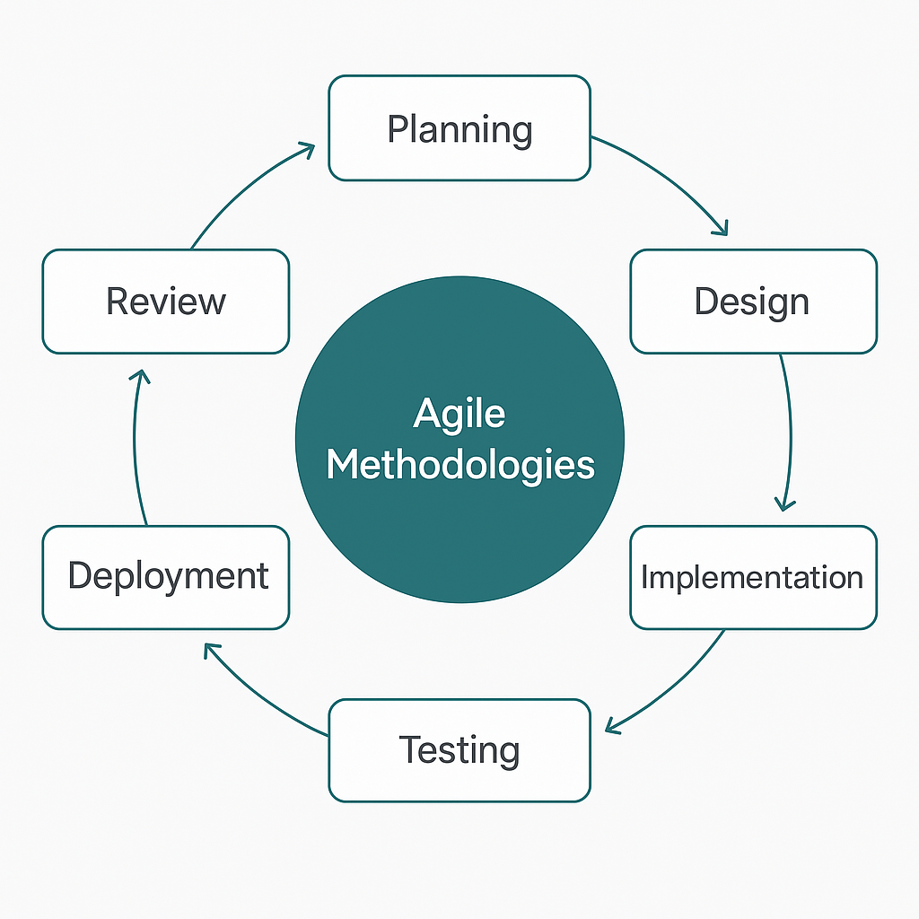

3.2 Data Analysis
Unlike traditional software development models, Agile promotes continuous feedback and adaptation, which means data is analyzed throughout the development life cycle. This allows the development team to remain responsive to changing requirements, feedback from real users, and emerging market dynamics. In the context of this platform, data analysis focuses on understanding farmers’ behaviors, local market trends, product demand, usability challenges, and technology access levels.
The research will use qualitative and quantitative methods for efficiency. Such as user Interviews and Focus Groups: Conducted with farmers and market agents to understand their pain points and workflows and Survey Forms: Captured data on smartphone usage, internet accessibility, preferred languages, and platform expectations.
Each Agile cycle begins with planning, where data from previous cycle (such as feedback or usage statistics) is analyzed to prioritize features. For example, if analysis shows that 70% of users prefer local language support, then implementing multilingual functionality becomes a top priority in the next cycle.

Figure 1.5 Data Analysis
Data Collected | Source | Insights Gained | Feature/User Story Developed
Farmers lack real-time pricing information | Farmer interviews, surveys | Need access to dynamic market prices | “As a farmer, I want to view daily market prices online”
Difficulty in connecting with buyers | Farmer groups, cooperatives | Lack of visibility and communication tools | “As a farmer, I want to post products for sale”
Low literacy and tech skills among some users | On-site observations, NGO input | Simpler UI and multilingual support needed | “As a farmer, I want to use the platform in local language”
Desire for buyer trust and traceability | Buyer feedback | Need for profile verification and product history | “As a buyer, I want verified farmer profiles”
Farmers want delivery tracking after selling | Cooperative leaders, extension agents | Need for simple order and delivery tracking system | “As a farmer, I want to track orders made by buyers”
Farmers worry about data cost and access | Rural community focus groups | Platform must work in low-bandwidth conditions | “As a farmer, I want to access the platform offline or via SMS”

3.3 System requirement specification (SRS)
The Software Specification, is a key component in the software development life cycle. It outlines in detail what the system should do without specifying how it should be implemented.
The SRS defines the functional and non-functional expectations of the platform from the stakeholders’ perspective. It is crucial for guiding developers, testers, and stakeholders throughout the Agile development process.
    - Functional Requirements
User Registration and & Login; Farmers and buyers must be able to register and log in using secure credentials. The platform will also support multilingual support for local languages.
Product Listing Management; Farmers can list produce with details like quantity, type, location and price.
Market Price Dashboard; Real-time access to current market prices based on region and product type.
Order Management; Buyers can place orders; farmers can accept, reject, or fulfill them.
Messaging System; In-app communication between farmers and buyers for negotiation or clarification.
Admin Panel; For managing users, monitoring platform activity, and updating market data.
    - Non-Functional Requirements
Usability; The interface must be simple and easy to navigate, even for users with low digital literacy.
Performance; The platform should handle at least 1000 concurrent users without lag.
Security; Data encryption for user accounts and transactions. And also, Secure login and data storage practices.
Scalability; Designed to support more users and features in future releases.
Availability; 99% uptime with offline access to limited features.

3.4 System Design
To be able to develop a web-based platform that supports local farmers in accessing broader markets, the system must be designed in alignment with the functional and non-functional requirements. The design process is divided into two key levels: Logical Design and Physical Design, each addressing different aspects of the system’s architecture and operations.
3.4.1 Logical Design
Logical design provides an abstract representation of how the system works. It focuses on data flows, inputs, and outputs. The system is designed around several key modules: User Management, Product Listings and Market Pricing.
Data Flow: Information flows from user inputs such as a farmer posting a product, through system processes (checking buyer matches), and then to outputs.
Inputs: Farmers input product data, buyers input search or order queries, and administrators input market updates.
Outputs: The system outputs price trends, buyer matches, order confirmations, and user notifications.
Logical models such as Data Flow Diagrams (DFDs) and Entity-Relationship Diagrams (ERDs) represent the interaction between users, data, and the system.
3.4.2 Physical Design
The Physical Design deals with how the logical design is implemented in the real world, focusing on system requirements, user interaction, data storage, and processing.
1. Input Requirements
Farmer Inputs: Web forms allow farmers to add and update product information, such as crop name, quantity, price, and description. Farmers also have the option to upload a CSV or Excel file containing bulk product details. The dashboard provides a personalized interface where farmers can track inventory, orders, and revenue.
Buyer Inputs: Buyers can filter products by type, price, distance, or availability using search filters. Order forms provide a simple way for buyers to specify quantities, delivery address, and payment method.
Admin Inputs: Administrators use the admin panel to input and modify platform settings, such as product categories, payment gateways, and shipping options. Administrators can also create, deactivate, or suspend user accounts through user management.
- Output Requirements
Farmer Outputs: Farmers receive valuable outputs from the platform to help them manage their sales and business. Such as Product listings and order Confirmation.
Buyer Outputs: Buyers receive outputs that facilitate their purchasing experience. The system provides dynamic, real-time listings of products based on buyers' search criteria. This ensures that buyers see the most relevant and up-to-date product information, making it easier for them to find what they need.
Admin Outputs: Administrators receive outputs that provide them with a comprehensive overview of the platform's performance. The platform dashboard provides a high-level view of key activities, such as the number of user registrations, the status of orders, and overall financial performance.
- Storage Requirements
The platform's data is stored in a relational database (e.g., MySQL, PostgreSQL). This structured database is designed to store all platform data, ensuring data integrity and efficient retrieval.
The database is organized into several tables; Farmers: Stores farmer details. Products: Stores product details, linking to farmers. Buyers: Stores buyer details and order history. Orders: Stores order-related data (buyer, product, quantity, status). Payments: Stores transaction details related to order payments. Admin: Stores admin user details and permissions.
To ensure data recovery in case of failure, regular backups of the database are crucial. These backups are performed daily and stored securely in a cloud service. This backup and recovery strategy helps to minimize data loss and ensure business
4. Processing Requirements
Product Listings: When a farmer lists a new product, the system stores the product's details in the database and makes it available for buyers to view.
Search: The system performs a query on the Products table based on the buyer's search criteria e.g., crop type, price range.
Order Handling: Once a buyer places an order, the system updates the Orders table, notifies the farmer, and updates inventory.
5. System Control and Backup/Recovery
Backup Strategy: As orders are placed and payments are processed, data is backed up immediately to avoid data loss.
Recovery Mechanism: If the system crashes, users can log back in to their accounts and continue their actions. Admins should have recovery tools for database restoration
Class Diagram
Used to represent the static structure of a system. It provides a blueprint of how different classes, attributes, methods, and relationships interact within a software application

Figure 1.6 Class Diagram

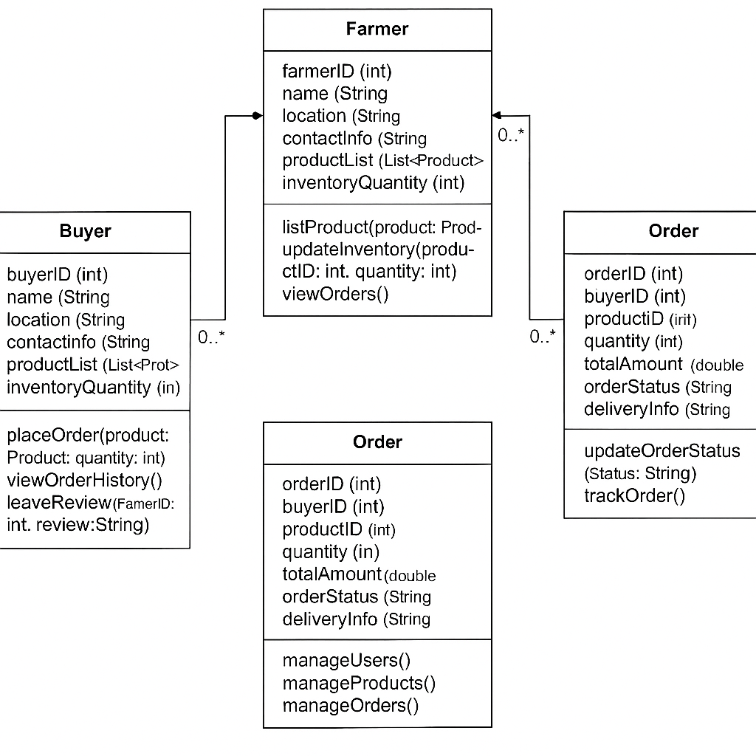

Entities
Farmer: Entity representing individual users who list products and sell them to buyers.
  - Attributes: Farmer_ID, Name, Location, Contact_Info, Product_List, Inventory_Quantity.
Buyer: Entity representing users who purchase products from farmers.
  - Attributes: Buyer_ID, Name, Location, Contact_Info, Order_History, Reviews.
Product: Represents the products (e.g., crops) being sold by farmers.
  - Attributes: Product_ID, Farmer_ID (foreign key), Product_Type, Quantity_Available, Price, Description.
Order: Represents an order placed by a buyer.
  - Attributes: Order_ID, Buyer_ID, Product_ID, Quantity, Total_Amount, Order_Status, Delivery_Info.
Admin: Platform administrators who oversee the system's functioning.
  - Attributes: Admin_ID, Name, Role, Permissions.
User Interface (UI)
The platform is designed with simplicity and clarity in mind, ensuring ease of use for farmers:
Input Methods: Users can input data using simple forms, dropdown menus, and guided inputs
Output/Information Display: Information such as market prices is displayed in a clean dashboard layout.

Data Design
The platform uses a well-structured database system to store and manage data efficiently and securely:
Data Representation: Data is stored in relational tables (e.g., Users, Crops, Prices). Each table uses clear identifiers and structured fields (e.g., user_id, crop type).
Storage: Backup and recovery mechanisms are in place to prevent data loss. Sensitive data (e.g., user credentials) is encrypted at rest and in transit.
Process Design
The system processes data through a series of well-defined steps to ensure accurate, secure, and timely information delivery:
Data Flow: Input from the user is captured via the UI and sent to the backend for validation and processing. Data flows through APIs and services that fetch or update information from the database. Output is generated and sent back to the frontend for display.
Validation: Input data is validated on both client and server sides to prevent errors and ensure integrity. User authentication ensures only authorized access to personal or sensitive information.
Security: Role-based access control is implemented for different user types (e.g., admin, farmer, expert). Regular security checks and updates are scheduled.
Transformation: Raw data (e.g., sensor data or uploaded images) is transformed using processing algorithms or AI models to generate useful insights (e.g., soil quality assessments, pest identification).

Ethical Considerations
All participants will have to consent before participating in the study. Data confidentiality will be maintained throughout the research process. The research will follow all ethical guidelines and regulations.

References
Pressman, R. S. (2020). Software Engineering: A Practitioner's Approach (9th ed.). McGraw-Hill Education
Software Engineering: A Practitioner's Approach (9th ed.). McGraw-Hill Education
Katidhan January (2024) The Impact of E-Commerce Platforms on Agriculture. Article Published online. (Katidhan 2024)
The Influence of E-Commerce Platforms on Sustainable Agriculture Practices among Smallholder Farmers in Sub-Saharan Africa - MDPI www.mdpi.com

